  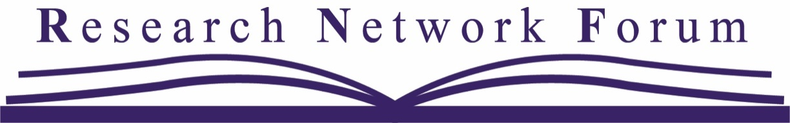
  April 3, 2024
  research network forum @ CCCC
  IN-PERSON in SPOKANE, WASHINGTON
  CALL FOR PROPOSALS
  The 37th Annual RNF includes:
  - Work-in-Progress Presenters sharing research in 8–10-minute presentations at Thematic Roundtables
  - Discussion Leaders, national senior researchers and scholars, mentoring Work-in-Progress Presenters
  - Editors discussing how to get research published, and
  - Networking opportunities for all who attend.
  RNF is FREE for those registered for CCCC. You can appear on the RNF Program and have a speaking role at CCCC.
  - If you are unable to commit to the entire day, please make sure you indicate your availability for the AM or PM session.
  - RNF often meets the same time as TYCA, ATTW, IWCA & other various CCCC workshops. Please do not double-book!
  - RNF is not set up for co-presenters (trust us—it doesn’t work!). Please submit ONLY individual Work-in-Progress Presentation proposals.
  - If a department is sending multiple graduate students, please send faculty Discussion Leaders to RNF who will work with people from other programs.
  Proposals Accepted until November 20, 2023
  http://researchnetworkforum.org
  Participate as any/all
  of the following by filling out a form for each role:
  Work-in-Progress Presenter [WiPP]
  Roundtable Discussion Leader [DL]
  Editors’ Roundtable [Editor]
  Risa P. Gorelick,
  Jennifer K. Johnson,
  & Carrie Wastal,
  RNF Co-Chairs
  Questions? Email: rnfchairs@gmail.com

