**Info for this year’s Call For Papers (CFP)**

Submission Link:

<https://docs.google.com/forms/d/e/1FAIpQLSeQZPfNnElMMIJ1F1wyiK6GDzY3EkonYgkTQoYdFDMoDDoWMg/viewform?usp=sf_link>

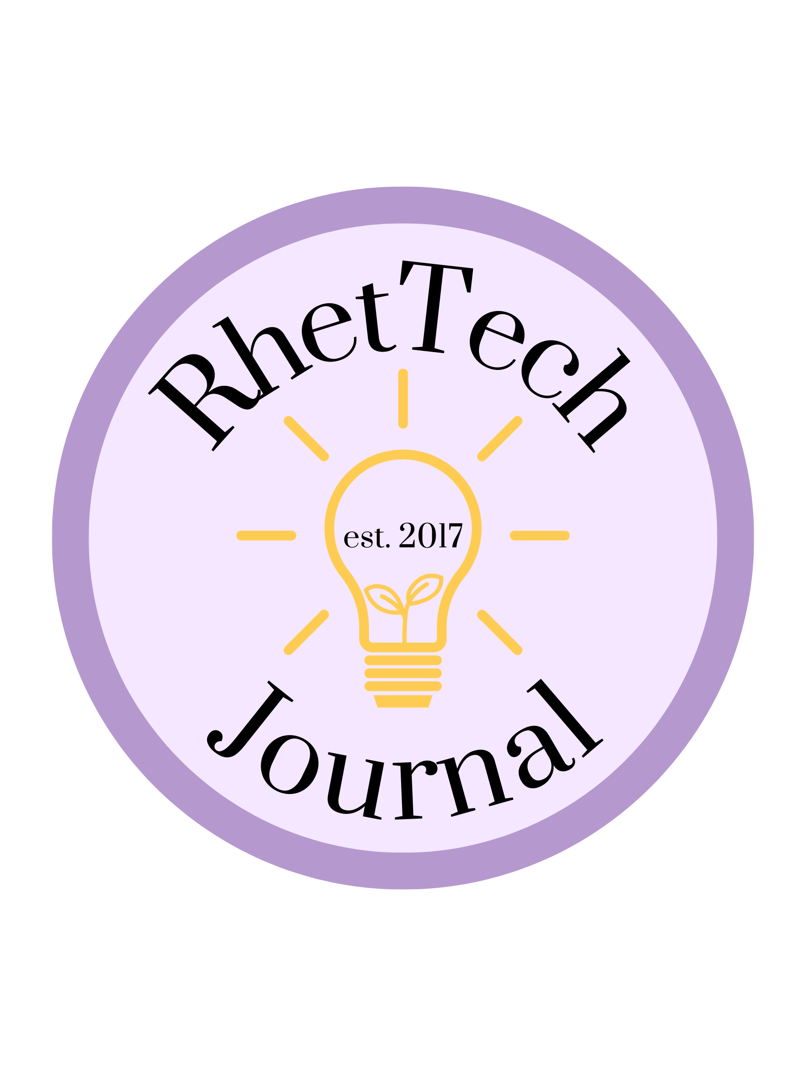

Are you interested in sharing your perspective on a topic you’re passionate about? Are you looking to gain notability by publishing your work? Then consider submitting your writing to James Madison University's undergraduate journal *RhetTech*! The journal aims to highlight the work of undergraduate students in the disciplines of writing, rhetoric, and/or technical communication. Regardless of where you are in your undergraduate career, *RhetTech* is a great opportunity to have your work published in a peer-reviewed journal.

We accept a variety of content in a range of formats, including videos, podcasts, photo essays, reviews, websites, blogs, text-based essays, and more. Submissions are primarily accepted during the fall semester of each academic year, and each new issue is published near the end of the spring term. For the 6th volume, **we are currently accepting rolling submissions.**

For this year’s volume, we are planning a special issue on the broad theme of “**Emerging Trends in RhetTech.**” Of course, there are a wide variety of topics that fit with our theme, and we encourage you to interpret it broadly.

That said, here are some potential questions we think would be worth exploring:

Broad examples

* What are the different ways that journalism and technical writing can be represented?
* How is media changing today? (In graphics, podcasts, articles, etc.)
* How is the language of writing changing in light of modern technologies?
* What ethical dilemmas arise from emerging technologies?
* What are the conflicts of interest in technological advancements?

Day-to-Day lifestyle

* How do present day writing practices compare to those of the past?
* What’s being taught in your classes? Describe an impactful course or concept that has changed the way you view rhetorical and/or technical writing.

Future of the field

* With emerging technologies, how is the face of journalism changing? In other words, how has journalism adapted to open access public publishing.
* How is A.I. changing the future of the field?
* In the past, most journalism available to the public subscribed to the “[Journalism Code of Ethics](https://www.spj.org/ethicscode.asp),” enforced by publishers. How does the increase in freelance work, in both informational and opinion pieces, differ from journalism previously governed by the prescribed code of ethics?

These are meant as examples of topics only and, again, **we want writers to interpret our theme of “Emerging Trends in RhetTech” in their own way.**

***Why submit?***

* Publication in a peer-reviewed journal
* Exposure to a national audience
* Feedback from a dedicated team of editors
* Experience writing for a professional peer-reviewed journal
* Opportunity to start a dialogue with other students of rhetoric, writing, and/or technical communication

To learn more about *RhetTech* and/or submit your work, visit: <http://www.jmu.edu/wrtc/students/undergraduate/rhet-tech.shtml>