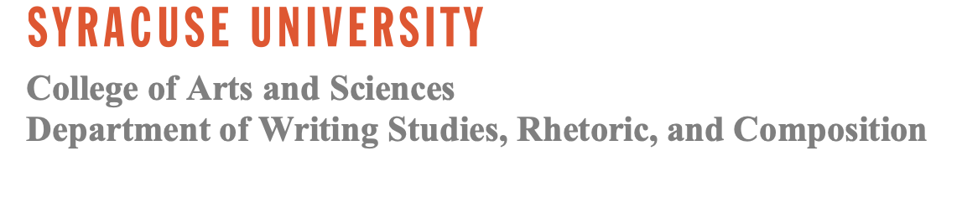****

**Protocol Title:** Disabling Structures: Graduate Students and Disability

**Principal Investigator/Key Research Personnel:**

Principal Investigator: Krista Kennedy, Associate Professor of Writing & Rhetoric

[krista01@syr.edu](mailto:krista01@syr.edu)

239 H.B. Crouse Hall

Student Researcher: Gabriella Wilson, Ph.D. student in Composition and Cultural Rhetoric

[gawilson@syr.edu](mailto:gawilson@syr.edu)

239 H.B. Crouse Hall

**Introduction:**

This form aims to provide participants with information about participation in a research study and offer them the opportunity to decide whether they wish to participate. Participants can take as much time as they wish to decide and can ask any questions they may have now, during, or after the research is complete.

This form is for the survey portion of the study. Participants will be asked to take a 25-question survey about their experiences in graduate school. The last question of the survey will ask if participants would like to participate in a voluntary 60-minute follow-up interview. Participation is voluntary for both the survey response and interview. Participants can also feel free to complete the survey but decline the interview request.

**What is the purpose for this research study?**

This study is interested in considering the cultural expectations in rhetoric and composition graduate programs and how those expectations shape disabled graduate students’ experiences. Gabriella Wilson is particularly invested in how disability and ableism impact how graduate students construct their professional and scholarly identity in the discipline, as a disabled graduate student herself. Graduate students are an understudied and often neglected population. So, this study hopes to lend insight into ableism in graduate education and how graduate programs can better create a culture of access in their programs. The research questions driving this study are as follows:

1. How do cultural expectations and discursive notions of productivity, efficiency, and ability impact disabled graduate students’ identity construction as they negotiate liminal spaces between teaching, research, and community?

2. How can listening to the ways that disabled graduate students practice resistance lead to structural recommendations for graduate programs that prioritize collective care and the development of a culture of access?

**What will participants be asked to do?**

Participants will be asked to respond to 25 survey questions. The survey will include various types of questions, including asking participants to scale their responses according to a Likert scale and open-ended text responses. The survey should take no longer than 30 minutes to complete. Participants who indicate interest in participating in interviews will be invited to the interview stage. Survey questions deal with experiences with disability and illness in graduate school.

**What are the possible risks of participation in this research study?**

For participating subjects, there may be minimal psychological risks as interviews could cause stress or anxiety considering the content of the research questions. Minimal social risk may also be involved if the participants' identities are discovered; however, all precautions are being taken to avoid this. Social risks may include increased prejudice against participants regarding their disability or experiences with ableism.

Additionally, even with anonymization, there may be a risk that some information could be attributed to a person because it is a small field. With this in mind, Gabriella will take every possible precaution to prevent that, and Gabriella will discuss with the participants if they have any particular ways to protect their identity by altering particular identity markers.

Whenever one works with email or the Internet, there is always the risk of compromising privacy, confidentiality, and/or anonymity. Participant confidentiality will be maintained to the degree permitted by the technology being used. It is important for participants to understand that no guarantees can be made regarding the interception of data sent via the Internet via third parties. To mitigate risk, Gabriella Wilson will be the only person with access to data and materials. All data and materials will be transferred from a password-protected laptop to an external hard drive disk that will be locked in Gabriella Wilson’s private residence.

**What are the possible benefits of participation in this research study?**

This research may be beneficial to participants in that it may give them time and space to reflect on how disability has impacted their experiences in graduate school. This research may better inform graduate programs of how to help disabled graduate students as they navigate graduate school, in turn helping disabled graduate students now and in the future.

**How will participant privacy be protected?**

Participants should be advised to complete the survey in a private location so others cannot overlook.

**How will participant data be maintained to ensure confidentiality?**

Survey participants will be identified with pseudonyms, and data will be stored in accordance with each pseudonym. Only Gabriella Wilson will have access to this data and to the key matching participant names to pseudonyms. That key will be stored in an encrypted hard drive. Survey responses, IP addresses gathered from survey responses, names, and any other identifying information will be anonymized and removed prior to sharing data with the PI, Krista Kennedy. The anonymization key will be kept on an encrypted hard drive that will be locked in a private location in Gabriella's home. Survey responses, participant information, and researcher notes will be transferred from a password-safe laptop to an encrypted external hard drive. They will also be maintained by a Qualtrics account accessed only by Gabriella Wilson.

Any participant information collected as part of the research, even if identifiers are removed, will not be used or distributed for future research studies**.**

**What are my rights as a research participant?**

* Your participation is voluntary.
* You may skip and/or refuse to answer any question for any reason.
* You are free to withdraw from this research study at any time without penalty.

**Whom may I contact with questions now, during, or after the research is complete?**

For questions, concerns, or more information regarding this research, participants may contact Krista Kennedy ([krista01@syr.edu](mailto:krista01@syr.edu)) or Gabriella Wilson ([gawilson@syr.edu](mailto:gawilson@syr.edu)).

If participants have questions or concerns about their rights as a research participant, contact the Syracuse University Institutional Review Board at (315) 443-3013.

**I am 18 years of age or older, and I understand what my participation in this research involves. I have printed a copy of this form for my personal records.**

**By continuing, I agree to participate in this research study.**