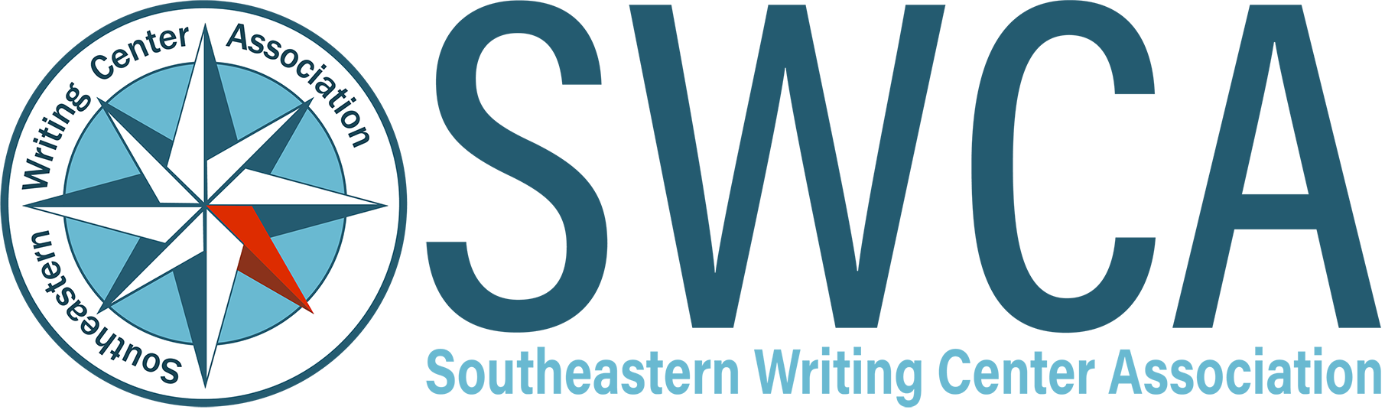

The Southeastern Writing Center Association is excited to announce that it will begin to offer its annual conference virtually every other year, beginning in 2026. The Board believes this will make conference attendance more affordable and accessible for members. SWCA’s virtual conference will be coordinated with IWCA’s virtual conference schedule, so that each year, there will be one in-person and one virtual option for members.

The Board is now seeking a chair(s) for our 2026 virtual conference, which will take place fully online in February. Virtual conference chairs should be at an institution located within the Southeast. The chair will have the same privileges and responsibilities as in-person hosts, as outlined in the organization’s [Bylaws](https://southeasternwritingcenter.wildapricot.org/Bylaws) (sections 28-29). SWCA also provides a budget for hosting the conference.

In addition to normal conference duties, virtual conference chairs are also responsible for managing the online components of the conference, including:

* Providing clear accessibility guidelines for conference submissions and presentations
* Determining the modalities and formats of online presentations (e.g. synchronous sessions and asynchronous, pre-recorded sessions), and providing clear guidelines and expectations for each
* Creating and managing the online platform(s) where attendees will access all conference presentations and content
* Providing moderators and other technical support for conference sessions throughout the duration of the event

If you are interested in hosting the virtual conference in February 2026, please send a conference proposal to the SWCA President, Candis Bond ([cbond@augusta.edu](mailto:cbond@augusta.edu)) by September 1, 2024. Proposals should include the following components:

* Draft of the conference CFP, including the proposed virtual platform, such as Zoom, dates, and proposed keynote and/or plenary speakers
* A written rationale theorizing the conference theme
* Committee information
* Budget, including anticipated costs for any online platforms, technological support, or accessibility resources that may be used. If using Zoom, for example, include any costs associated with increasing SWCA’s organizational account or your institution’s account to have the capacity to support multiple simultaneous sessions and 300+ attendees. Hosts may also want to use a platform such as Whova or pay for translation services. These are just some examples of costs associated with hosting a virtual conference.

The Executive Board is happy to meet with interested parties ahead of the deadline to brainstorm ideas and answer questions. More information, including sample proposals, can be found on SWCA’s [“Call for Conference Hosts”](https://southeasternwritingcenter.wildapricot.org/Call-for-Conference-Hosts) webpage.