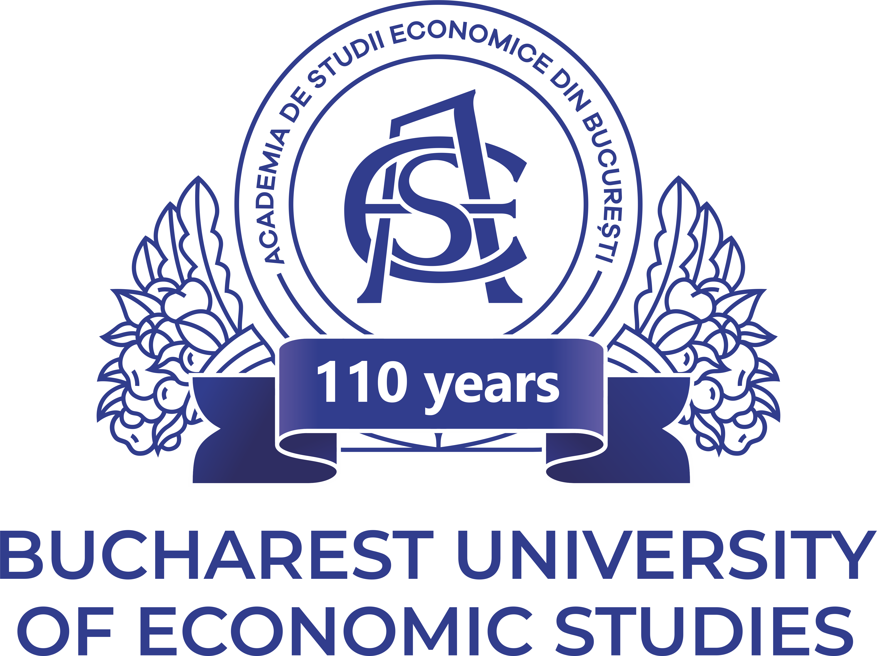 |  |  |  |  | 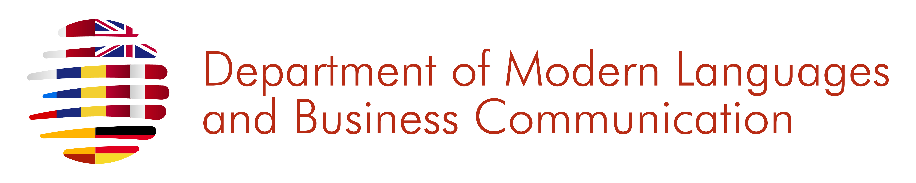
in partnership with
 |  | 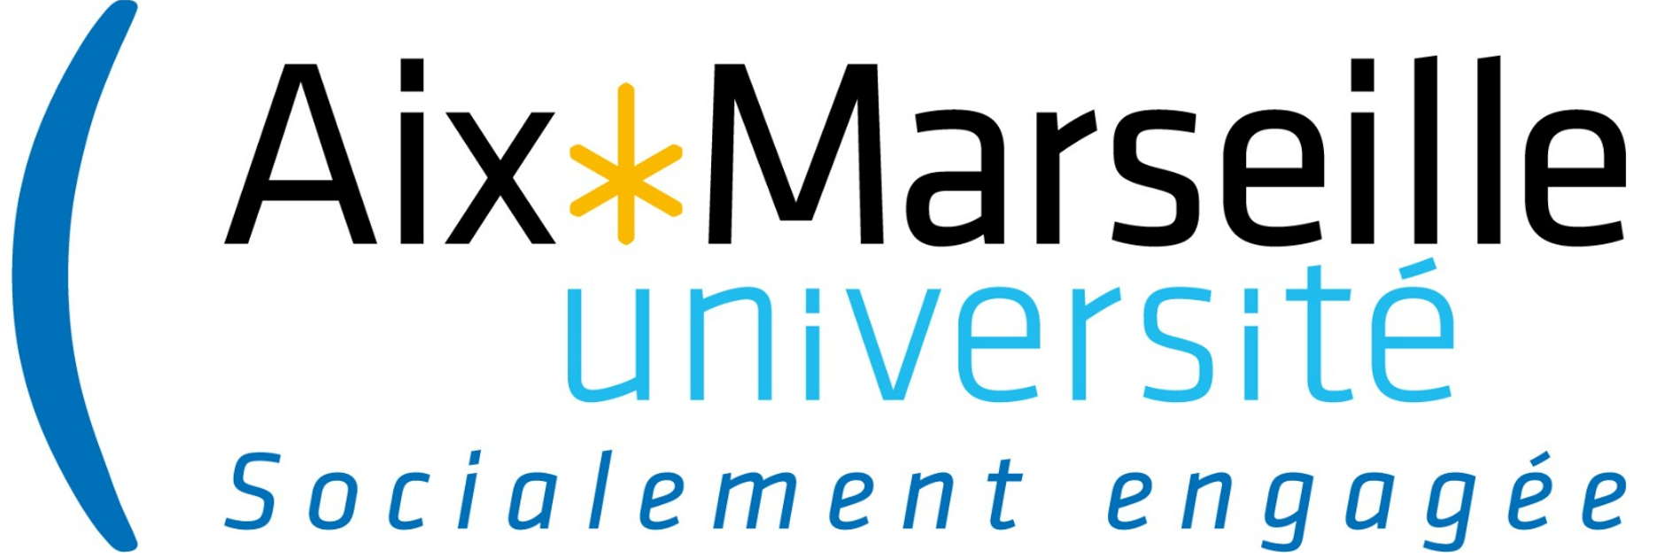 |  |   SOA | SIKSHA 'O' ANUSANDHAN |  |  |  | 

CALL FOR PAPERS
The 12th International Conference
Synergies in Communication (SiC 2024)
31 October- 1 November 2024
(hybrid format)

The Department of Modern Languages and Business Communication of the Bucharest University of Economic Studies (ASE), Romania, is organizing the 12th annual international conference Synergies in Communication (SiC 2024), to be held in a hybrid format on 31 October- 1 November 2024. The event will be organized under the auspices of the Faculty of International Business and Economics in partnership with Université d'Artois, University of Zaragoza, Aix-Marseille Université, Siksha ‘O’ Anusandhan University (SOA), Hiroshima University, “B.P.-Hasdeu” Institute of Romanian Philology, Ministry of Education, Culture and Research in Moldova, “Ovidius” University of Constanta and QUEST Romania, PROSPER-ASE Language Centre, The Romanian Society for English and American Studies (RSEAS), a member of The European Society for the Study of English (ESSE), Romanian Association for American Studies (RAAS) .

The conference is organized around 7 thematic areas:

section 1: Synergies in LINGUISTICS, business AND (INTER)CULTURAL communication.

(online)
Communication is a synergistic field where effectiveness is given by knowledge from diverse domains and by the ability to align best practice with the increasingly rapid pace of the world today. Moreover, today, universities face the challenge of meeting their dual role as institutions of culture and higher education as well as providers of knowledgeable, flexible, autonomous and self-determined graduates for the labour market. This section of our conference welcomes discussions on topics related to the following main areas:

- Current developments in academic and research communication
- Linguistics, sociolinguistics and (inter)cultural communication
- The language of modern media
- Language and literature in the cultural and linguistic space
- Literary and cultural studies; analyses of culturally determined values, mentalities, actions, attitudes etc.;
- Theory and practice in (inter)cultural education;
- Business communication - intercultural dimensions and specific skills demanded on the labour market.
- The inter-disciplinary dimension of business communication – changing mentalities through environmental education.
- Translation studies;
- Traductology and terminology in business and economics;

Email: sic.section1@gmail.com

section 2: INTERDEPENDENCES: ACADEMIC AND DIGITAL LITERACIES IN THE NEW EDUCATIONAL AND RESEARCH ENVIRONMENT. REVISITING QUALITY IN HIGHER EDUCATION

(online)
This section provides an interdisciplinary forum for specialists in various fields to share expertise and to reflect together on ways forward, in the current academic context, with all its challenges and opportunities. This section will be organised in partnership with the “DILAN” Project, the University of Zaragoza, the Doctoral School of Humanities of “Ovidius” University Constanta, and the Romanian Association for Quality Language Services QUEST. Possible topics include (but are not restricted to):
          - Academic literacy development – case studies from different international contexts;
          - New developments in communication, study, teaching, assessment, and professional development in the digital era;
          - Quality related aspects in the new educational and research environment - drawing inspiration from the International Association Eaquals - Evaluation and Accreditation of Quality in Language Services;
          - New perspectives on academic networking and research dissemination through “DILAN” - Digital Language and Communication Training for EU Scientists.
Email: sic.section2@gmail.com

section 3: Romanian cultural and linguistic studies

(Online)

Romanian academia play an important role in building bridges between values, traditions and representations attached to Romania and to other cultural areas - in Europe or worldwide. We propose to focus on the presence of Romanian culture in other countries, to strengthening connections between Romania and other cultures, to the teaching of Romanian culture and language to foreigners in Romania and abroad, with a view to using such cultural and linguistic knowledge in a multicultural context. Papers are invited on, but not limited to topics such as:
- Romanian cultural studies – literary, translation, socio-linguistic, pragmatic studies;
- Teaching Romanian as a foreign language – theory and practice;
- Enhancing Romanian and foreign students’ awareness of each other’s cultures, as a prerequisite for academic and professional mobility, as well as social and cultural inclusion.

Email: sic.section3@gmail.com

section 4: BOUNDARY TRANSGRESSIONS IN BETWEEN EAST AND WEST

(hybrid)
Transgression has become a reality of our times, encoded in various modes of interconnectedness afforded by this age. Whether at home or abroad, the inherent transcendence of (trans)cultural dynamics intersects with transgressive mechanisms that facilitate the contestation of hegemonic discourses. One the one hand, the idea of transgression carries geographical connotations, given its literal significance of crossing a boundary. On the other hand, at a symbolic level, the crossing of a threshold marks a step to an out of place status that contains potential for resistance within the confines of a single culture. Transgression dissolves ossified structures and patterns, revealing novel perspectives. This opens towards a fruitful interpretation of its labyrinthic nature along various lines of analysis: postcolonial, Foucauldian, or Bakhtinian, to name a few only. An important coordinate of the proposed analysis considers the relation between settlement/mobility, space and gender, questioning the subversive potential of women’s rootedness vs. motion. Given this context, we invite contributions related, but not limited to:
- The Self and the Other;
- Popular culture and visual anthropology;
- Women’s identity and memory;
- Psychology and trauma studies;
- Image, imagination and imaginary worlds;
- Colonial and postcolonial studies / translation studies;
- Literature and the socio-political context
- Cultural globalization, hybridity and locality
- Settlement, nomadism, (non)conformism.
Email: sic.section4@gmail.com

section 5: Mindscapes and Cultural Insights in Far Eastern Studies

(online)

Focusing mainly on Far Eastern Studies, spanning from China and Korea to Japan, this section is designed not only as a debating venue on tradition, cultural representations, and academic challenges in a volatile contemporary context, but also as an interdisciplinary nexus for specialists willing to share their new ideas, research results, and latest in-depth scholarship on various topics such as:

  - Literary research and interpretation; Comparative literary studies; Translation studies; Semiotics;
  - Linguistics, education, and language teaching;
  - Cultural studies; Gender studies;
  - Anthropology, mythology, and folklore;
  - Media and pop-culture; Communication; Digital humanities etc.

Email: sic.section5@gmail.com

section 6: MULTIDISCIPLINARY APPROACHES TO THE HUMAN EXPERIENCE

(online)
What does it mean for each of us to be a human being? How do we perceive ourselves? How do we perceive others? What makes us act in a certain way? How do we relate to the people around us or to the context in which we live? This section of the conference tries to find the answer to all these simple, yet puzzling questions that touch all the intricacies, contradictions and mysteries of life. The panel intends to be a celebration of the human experience, with all its complexities, thrills and wonders. We welcome submissions that explore all aspects of this topic from various academic fields: literature, religion, culture, arts and media, psychology, pedagogy, etc. The themes for the session include, but are not limited to the following suggestions:
- The human condition: destiny, free will, the meaning of life, life as a journey, the human nature, etc.
- Self-discovery: identity and difference, belonging, language, memory, collective identity, etc.
- Individual and collective experiences: growth, finding one’s own place, a new beginning, marriage, motherhood, change, adaptation, struggle, pain, loss; community life, human relations, conflict, borders
- Complex emotions: love, passion, joy, happiness, awe, sadness, loneliness, jealousy, guilt, despair, etc.
- Human motivation and behaviour: ideals, beliefs, mindsets, manners, practices, ways of behaving
- The role of education or storytelling in shaping the human experience/ the human nature
- Experiencing different realities: religious, utopian, dystopian, fantastic, mythical imaginaries and dreams

Email: sic.section6@gmail.com

section 7: Migration, Diaspora(s), and Refugees

(online)
Migration, either in theory or in practice, and its sub-fields, diasporas and refugees, are by no means a domain of the past. In 2020, according to the International Organization for Migration, the number of migrants reached 280 million people, representing 3.60% of the world population and figures are on the rise. If migration has been seen as a phenomenon that involves a political act due to the individuals’ and communities’ personal or national affiliations, therefore portrayed moreover as a cause that triggers consequences post migration, it is more frequently seen these days as a consequence of conflictual, aggressive and even confusing politics. We expect participants to contribute with academic papers, posters, and other kinds of visuals that illustrate international migration, migrant integration, managed migration, asylum, family migration, children migration, and (temporary) protection. This interdisciplinary panel includes:
• Economics
• Politics
• Legal Studies
• Sociology
• Anthropology
• Literature Studies
• Film Studies
Email: sic.section7@gmail.com

INFORMATION FOR AUTHORS

Conference languages: English, French, German, Italian, Spanish or Romanian. The abstracts will go through a peer-review process, followed by a notification of acceptance or request for revision.
The authors who are interested in publishing their papers are responsible for preparation of the manuscripts according to the guidelines provided. Each participant can submit maximum 2 papers as author or co-author.

Submitted full papers are subject to a double-blind peer-review process. All review comments and suggestions should be addressed in the final submission, otherwise the manuscript might be rejected at the final review stage. We request that you submit both a marked-up version (with revisions highlighted or indicated with ‘track changes’) and a “clean” version of the manuscript. The papers submitted for publication must be original, not previously published or currently submitted for publication elsewhere and they must not plagiarize or infringe the copyright of anyone.

PUBLICATION

The accepted articles will be published in the International Conference Synergies in Communication Conference Proceedings Series (with print and online ISSN) by ASE Publishing House and currently indexed in the following IDB: CEEOL, EBSCO Discovery Service, Elektronische Zeitschriftenbibliothek Regensburg (EZB), ROAD, The Linguist List, Crossref Database, Dimensions, Modern Language Association (MLA), Cosmos and MIAR. (see: https://sic.ase.ro/index.php/international-data-bases/)

CONFERENCE FEES

Early registration till 10 October 2024 | 200 RON/ 40 EUR
Registration after 11 October 2024 | 250 RON/ 55 EUR
PhD candidates | 170 RON/ 35 EUR

Payments will be made by bank transfer according to the guidelines in the Registration Form (to be sent upon registration). A scanned copy of the payment receipt will be sent to the organizers after receiving the final acceptance notification.

KEY DATES
Submission of abstracts deadline | 15 October 2024
Notification of abstract acceptance | ongoing
Full paper submission | 20 November 2024
Notification of full paper acceptance | 28 February 2025
Publication of Conference Proceedings volume | End of March 2025

Facebook page: ASE - Synergies in Communication Conference – SiC
Conference website: https://sic.ase.ro/
We look forward to receiving your abstracts and to seeing you in October!
The Synergies in Communication 2024 Organizing Team

Our partners for this academic event:
