# Call for Papers Southern Regional Composition Virtual Conference

# 28 March 2025

## Theme: Leaving a Legacy in Composition

We invite proposals for the fully virtual 2025 Southern Regional Conference on Composition, which brings together educators, researchers, practitioners, and students from across the region to explore critical issues in the teaching and study of composition. This year’s theme, “Leaving a Legacy in Composition” focuses on analyzing our legacies as composition specialists by emphasizing how the systems and approaches we establish today will shape the future experiences of students and education as a whole.

### Questions for consideration

* What is the legacy that this generation of rhetoricians will leave behind?
* How do we build student agency into our courses? Why is this important to us as a field?
* Is America’s traditional curriculum still relevant and for whom?
* Can we create legacy without reinforcing harmful patterns of tradition?
* What norms, traditions, boundaries do compositionists cling to and why?

Legacy is rooted in the past and all but synonymous with tradition. Let us engage, then, in critically examining what parts of our discipline carry forward legacy for good reason and in what ways our legacy might reflect the fallacy of tradition or ways in which our legacy might be adapted to better serve our discipline.

## 

## 

## 

## 

## 

## Keynote Speaker

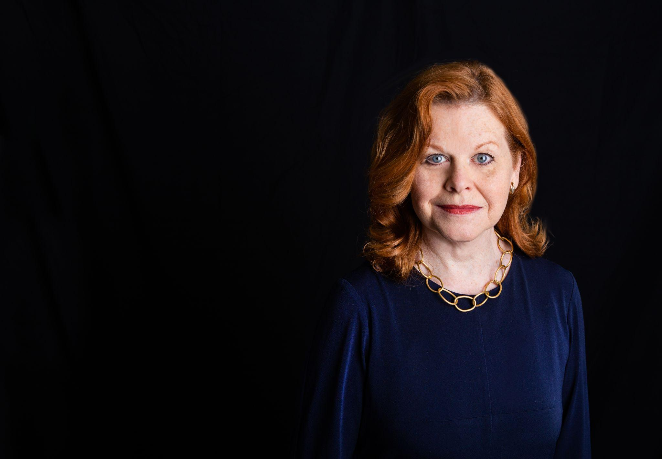

Dr Lynée Lewis Gaillet, Distinguished University Professor of English at Georgia State University, researches rhetorical history and composition pedagogy, mentoring issues, feminist activism, and archival research methodologies. Her book projects include The Present State of Scholarship in the History of Rhetoric, Stories of Mentoring, Scholarly Publication in a Changing Academic Landscape, Primary Research and Writing, Writing Program and Writing Center Collaborations, and Remembering Differently: Re-figuring Women’s Rhetorical Work. She is currently co-editing Blurred Boundaries: Gender, Identity, and Academic Labor in Times of Change addressing women’s labor post-2020. Gaillet has served as English Department Chair, Writing Program Director, Writing Center Director, President of the National Coalition of Feminist Scholars, and Executive Director of the South Atlantic Modern Language Association.

## Conference Details

The 2025 Southern Regional Conference on Composition will take place virtually and is hosted by Arkansas State University. This virtual conference provides an opportunity for professionals to engage in dynamic discussions about the future of composition teaching in higher education. More information about the SRCC and past conferences can be found at [www.southernregionalc](http://www.southernregionalcompositionconference.com/)[ompositionconference.com](http://ompositionconference.com/).

# Submission Guidelines

We welcome submissions that will help us identify and dismantle biases in our foundations and uncover strengths and weaknesses within our modern practices and that promote a positive legacy as American educators. Some questions to consider:

* How do we approach grammar in the context of World Englishes?
* How can institutions and departments, especially in the southern region of America, contribute to a new legacy for learners?
* In what ways are the colonial roots of "Academic English" helpful/harmful?
* Is AI-generated text the student's product? How can we encourage ethical use of AI in students’ writing processes?
* Are western argument structures still relevant? Should they be? Is there room for other approaches?
* What is the role of gender in (re)establishing inclusive pedagogy?
* What legacies in rhetoric and composition should be discontinued and why?
* How can the rhetoric of modern academia be reframed to promote equitable teaching practices, which would contribute to a positive legacy of inclusivity and empowerment?

We encourage submissions that offer innovative perspectives, story, case studies, and research that advance discussions about legacy, student agency, equity, tradition, and the future of composition studies.

### Topics of Interest

We welcome submissions on a variety of topics, including but not limited to:

* **Pedagogy and Practice**: Strategies for teaching composition and grammar to diverse student populations.
* **Technology in Writing Instruction**: Innovations and challenges in digital and multimodal composition.
* **Assessment and Feedback**: Effective methods for evaluating student writing and providing feedback.
* **Equity and Access**: Addressing issues of equity in composition classrooms.
* **Professional Development**: Supporting composition instructors in their professional growth.
* **Student Engagement**: Techniques for improving reading comprehension and critical thinking skills.

We encourage proposals for the following formats:

* **Individual Presentations**: 20-minute presentations on original research or pedagogy (250-500 word abstract).
* **Panels**: 3-4 speakers on a related theme (250-word abstract per speaker + 150-word summary).
* **Workshops**: Interactive sessions (500-word description detailing objectives and outcomes).
* **Digital Posters or Traditional Posters**: Visual presentations of research or instructional innovations (150-word abstract).

Please submit your proposal by emailing it to [srcompositionconference@gmail.com](mailto:srcompositionconference@gmail.com)by 15 January 2025. Proposals should include the following:

* Title of the presentation
* Name(s), institutional affiliation(s), and email address(es)
* Type of Proposal (poster, workshop, panel, presentation)
* Abstract (word count according to submission type)
* Brief biography (50 words)

### Selection Criteria

Submissions will be evaluated based on relevance to the conference theme, originality, clarity, and the potential for engaging attendees in thoughtful dialogue. Notifications of acceptance will be sent in February.

# Registration and Contact Information

Our registration link will be available in January,but please note that registration will be free for 2025. That said, you will be able to make a donation through our website if you would like to support future conferences.

## Contact Information

For more information about the conference or the submission process, please contact our board at [srcompositionconference@gmail.com](mailto:srcompositionconference@gmail.com). More information about the SRCC and past conferences can be found at [www.southernregionalc](http://www.southernregionalcompositionconference.com/)[ompositionconference.com](http://ompositionconference.com/).

### Important Dates

* **Submission Deadline**: 15 January 2025
* **Registration Deadline**: 10 March 2025
* **Conference Date**: 28 March 2025 with a virtual social on the evening of 27 March 2025