Call for Proposals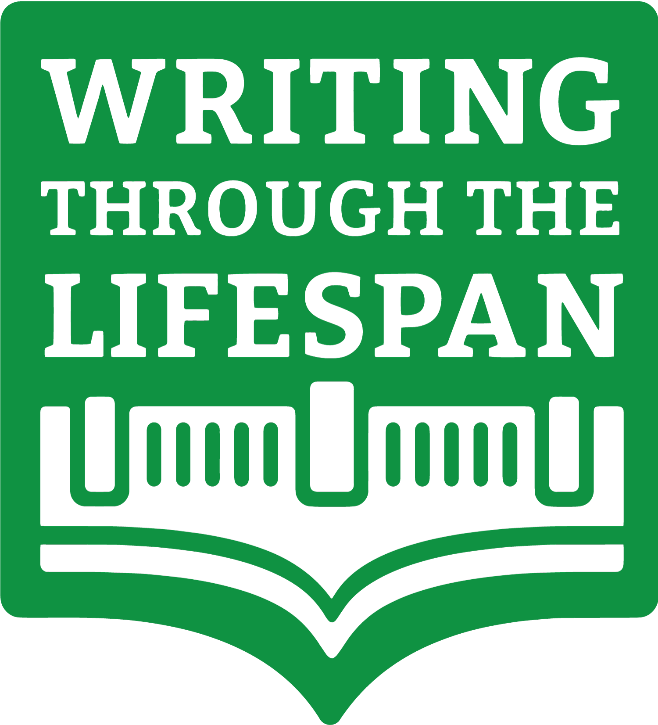

**The Writing Lives We Choose:   
Exploring Agency with Lifespan Writing Research**

**a special issue of *Writing & Pedagogy***

Guest Editors:

Ryan Dippre, University of Maine &

Talinn Phillips, Ohio University

The 2020s have been a time of global upheaval and unrest and the socio-political climate continues to uproot our communities and ways of understanding. As we try to build meaningful lives in the midst of so much chaos and uncertainty, we recall the comment by Marx (1852) that people “make their own history, but they do not make it just as they please; they do not make it under circumstances chosen by themselves, but under circumstances directly encountered, given, and transmitted from the past” (p. 63). An ongoing interest of ours—and one that is particularly salient at this historical moment—is how people go about their lives, and particularly their writing lives, among the exhausting, harrowing, and spirit-killing heave of historical change.

For this special issue, we invite manuscript submissions about how agency impacts writing lives for a special issue of *Writing & Pedagogy* on Lifespan Writing Research titled *The Writing Lives We Choose: Exploring Agency with Lifespan Writing Research*. We seek reports of empirical research (qualitative, quantitative, or mixed method), theory-building manuscripts that address any portion of the human lifespan, and reflections in pedagogical practice. We welcome scholarship from any cultural or national context (particularly those beyond North America). Prospective authors are encouraged to place their articles in conversation with current Lifespan Writing Research.

**Projected Timeline**

Submission of Manuscripts September 1, 2025

Manuscript Reviews October-December, 2025

Manuscript Revisions Due January 15, 2026

Publication Target August, 2026

**Submission Details**

Research manuscripts should be 7,500-9,000 (including references) and reflections in practice should be 4,000-6,500 using current APA style. Please direct queries about fit, timeline, etc., to the guest editors at [lifespanwriting@gmail.com](mailto:lifespanwriting@gmail.com). **Submit manuscripts by September 1, 2025 to** [**https://utppublishing.com/journal/wap**](https://utppublishing.com/journal/wap) **and note that they are for the LWR special issue.**