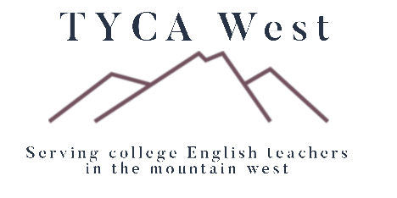

# CFP: TYCA-West virtual conference, June 12-13, 2025

# Beyond Boundaries: Coming Together in a Time of Division

In today's political and social climate, it seems like more attention is paid to the things that divide us than the things that bring us together. Beyond the obvious examples in politics, the examples of division in our field are explicit and seemingly omnipresent. The divide between full and part-time faculty and the attendant labor conditions those distinctions create is inescapable. We constantly renegotiate the boundaries of our regional organizations, including TYCA-West, which is welcoming California into our area. In our institutions, departments draw lines between each other that may not benefit our students so much as it does our senses of self. For this conference, we want to focus on what makes us alike. Whether you are from a large, urban, open access school or a small, selective, four-year school, whether you are housed in a department of English, languages, humanities, or something else entirely, we are all brought together by our belief that English communication is a vital skill for all of our students. This year, we move beyond physical spaces to the virtual world, to bring together as many people from as many different areas as possible, to share ideas, to grapple with difficult questions, and to focus on what really matters in our classrooms.

CFP: We invite individual presentations, panel proposals, short workshops, and poster sessions from any scholar who values the work done in writing and literacy at open access institutions. In the spirit of this call for papers, scholars from across the country are encouraged to apply, attend, and present their work**. 100-250 word proposals will be due May 15th** [**to this submission site**](https://forms.office.com/r/9W3HLbJLLZ)**, with decisions given by May 20th.**

**For more information and to connect with the organization, visit** [**https://tycaw.org**](https://tycaw.org)