TYCA-PNW 2025 Conference: Short Program

Registration and Accommodations
Please register for the conference here.

Conference rates
 | Early Bird (through Oct. 1) | After Oct. 1
Full Time Faculty | $110 | $125
Adjunct/Contingent Faculty | $60 | $75
Graduate Students | $60 | $75

Hotels
Best Western Premier Pasco Inn & Suites
2811 N 20th Ave, Pasco, WA, 99301
(509) 543-7722
Use this link to secure the $169.00 conference rate by September 20. After this date, select the “government rate” option.

Courtyard by Marriott Pasco
2101 W Argent Rd, Pasco WA, 99301
(509) 545-4011
State employees can select the "government rate" option.

Location and Parking
Columbia Basin College, SWL Building
2600 N 20th Ave
Pasco, WA 99301

Directions: The SWL Building is easily accessed from Argent Rd or Saraceno Way from Argent Rd.

Parking: Parking is free in designated student areas. (see the map on the last page)

Conference Schedule At-A-Glance
Time | Event | Location

Friday, Oct. 17
1:30-4:00 pm | Registration | 2600 N 20th Ave (take Argent Rd or Saraceno Way entrance)  SWL Building foyer
2:00-4:00 pm | Interactive workshop | SWL Building 117
4:30-6:30 pm | Wine social | TBD
Saturday, Oct. 18
7:30-8:30 am | Registration | SWL Building foyer  2600 N 20th Ave (take Argent Rd or Saraceno Way entrance)
8:00 am-4:00 pm | Continental breakfast, coffee and other beverages, and afternoon snacks available all day | SWL Building 117  2600 N 20th Ave (take Argent Rd or Saraceno Way entrance)
8:30-9:45 am | Opening Session/Keynote | SWL Building 121
10:00-10:50 am | A Sessions | SWL Building
11:00-11:50 am | B Sessions | SWL
12:00-1:15 pm | Lunch | Thornton Courtyard, T Building
1:30-2:20 pm | C Sessions | SWL
2:30-3:20 pm | D Sessions | SWL
3:30-4:20 pm | E Sessions | SWL

Friday’s Interactive Workshop
Using Multimodal Assignments to Support Constructivist Media Literacy
How can we help students move beyond consuming media to critically analyzing and creating it? This session explores practical strategies for designing multimodal assignments—podcasts, infographics, digital stories—that foster constructivist media literacy in English courses. Participants will engage in hands-on activities, examine adaptable assignment prompts, and leave with tools and resources to scaffold multimodal projects that promote deeper rhetorical awareness and critical thinking.

Sarah North, MLIS, Ed.S, M.S., Director for Library Services
Donny Anderson, M.S., M.Ed., Instructional Designer
Katie Bullock, M.A., Instructional Designer

Saturday’s Keynote
Compassionate Dispositions, Compassionate Practices: Community College Student Perspectives on What Makes Someone an Effective Literacy Teacher

This keynote address will present findings from a qualitative study of community college student perspectives on what makes someone an effective literacy teacher. Christie co-designed and co-conducted this study with a team of students from Salt Lake Community College who have participated in the college’s transfer bridge partnership with the University of Utah’s Department of Writing and Rhetoric Studies. In early 2025, the team interviewed 30 current SLCC students from a wide range of language backgrounds, identities, communities, and degree programs. This address will discuss two key interrelated themes from these interviews: compassionate teaching dispositions and compassionate practices. Drawing on interview findings and reflections from study co-researchers, Christie will share how the Department of Writing and Rhetoric Studies is using these findings to reimagine graduate education for future community college literacy faculty. She will invite conversation about how these findings might contribute to work in TYCA Pacific Northwest.

Christie Toth, PhD
Associate Professor and Coordinator of Transfer Initiatives and Community College Partnerships in the Department of Writing and Rhetoric Studies
University of Utah

CBC Pasco Campus Map
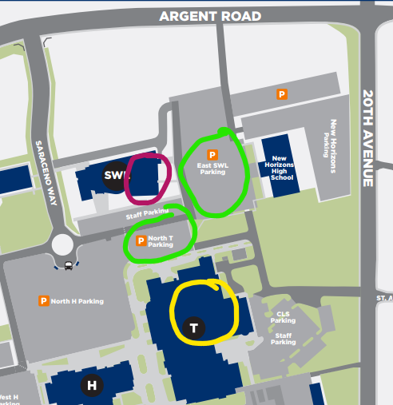
SWL Building for conference registration, snacks, keynote, and sessions
Parking options
T Building includes Thornton Courtyard (lunch location)
For a full map of campus, follow this link: https://www.columbiabasin.edu/_documents/maps/pasco-campus-map.pdf

